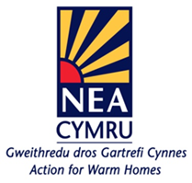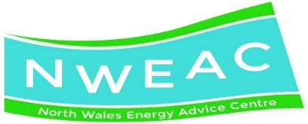****

Shelter Cymru -Fit for Rent? Today’s Private Rented Sector in Wales Report published in 2014,

Too many children are living in cold, damp unsafe private rented properties which is affecting their health, safety and wellbeing.

“Everyone deserves to live in a home which is safe, sound, warm and secure which they can live, grow, play and work in.”

* Poor housing -linked to increased levels of long term illness, respiratory and infectious diseases, injuries, psychological problems, perceived poor general health and increased mortality.
* 1 in 10 tenants said their health had been affected due to their landlord not doing repairs.
* 1 in 10 tenants with dependent children said their children’s health has been affected.
* Tenants in Wales were 19% more likely to have experienced damp; and 27% more likely to have experienced trip hazards.
* The strongest links being reported between illness in children and living in damp/mouldy conditions.

**How we can help**

Are any of your cases living in a home which is affecting their health and mental wellbeing?

Do they live in Flintshire?

* Do they own or privately rent their property?

If yes we can help.

We can provide information or advice on:

* heating issues, energy bills and fuel poverty
* damp and mould
* home safety - hazards and clutter
* outstanding repairs
* fire safety

Email: [HealthyhomesHP@flintshire.gov.uk](mailto:HealthyhomesHP@flintshire.gov.uk)

Phone: 01352 703445

**Useful contacts:**

**Domestic Energy Team**--Area based energy improvements, Flintshire Affordable Warmth and crises fund, Gas Connection Vouchers- 01352 703766 or email: [Leanna.Jones@flintshire.gov.uk](mailto:Leanna.Jones@flintshire.gov.uk)

**North Wales Energy Advice Centre**--Tariff advice, Reduce energy bills, Switching, Access to grants for new heating systems-01352 876040 or  
Freephone 0800 954 0658 or email: [steve@nweeac.org.uk](mailto:steve@nweeac.org.uk) or [laura@nweac.org.uk](mailto:laura@nweac.org.uk)

**Environmental Health-Housing Standards and Enforcement**- Disrepair -such As: Damp and mould, No heating, cold house, Issues with kitchen, issue with electrics, Landlord not doing the works-01352 703440 or email: [PPAdmin@flintshire.gov.uk](mailto:PPAdmin@flintshire.gov.uk)

**Housing Regeneration and Renewal**- Support to get repairs done via: Loans, Disable facilities Grants, Adaptations-01352 703434

**Care and Repair North East Wales**- Case worker support(fuel poverty, income maximisation), Adaptations, Repair/ improvement to own property, Hoarding, Grant funding-01352 758700 or email: [enquiries@careandrepairnew.co.uk](mailto:enquiries@careandrepairnew.co.uk)