The Quay Surgery

Language Line is supported by the Local Health Board. If an interpriter is require please let the reception team know.

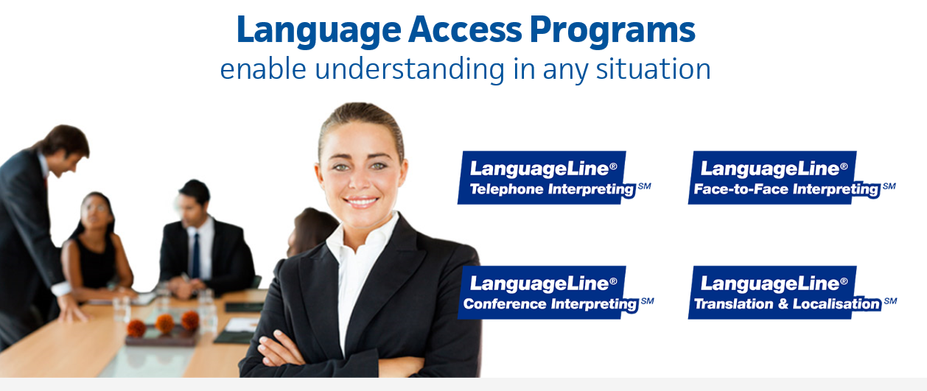

Enquiries to Language Line:- 0845 310 9900 Email:- enquiries@languageline.co.uk

ID Code:- L53248

